Hercules W2000 (DKW)
Thanks are due to Reiner Nikulski who submitted most of the material on this page.
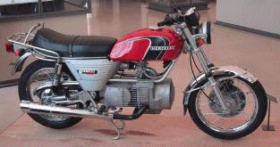
1975 W2000 at the Conservatoire des Arts et Metiers in Paris. Image from Darrell
The Hercules (Herkules) works have existed for more than 100 years and are one of the oldest motorbike works. They belong to the Sachs group who produce automotive products like clutches, shock absorbers and small engines for several purposes. Sachs was one of the first licensees of the new NSU / Wankel rotary engine in 1960. They developed and built more than 35,000 Wankel engines mostly for stationary purposes. Characteristic was the air-cooling and the charge-cooled rotor. The biggest one was the 294 cc KM 914 for generators and snowmobiles. This KM 914 was the basis of all Hercules and BSA (later Norton) rotary motorbikes.
The first Hercules W 2000 was shown at the German IFMA motorbike show in 1970 to see the public's reaction to a rotary bike. It had the Sachs KM 914 engine and a BMW gearbox and driveshaft. Only one prototype was produced.
In 1973 Hercules built 50 W 2000 in a "pre-series" and sold them only to Hercules dealers. It had the KC 24 engine, which was based on the KM 914 but was fitted for use in motorbikes. A six-speed gearbox with chain-drive was now installed. Characteristic for the pre-series bikes was the yellow fuel tank.
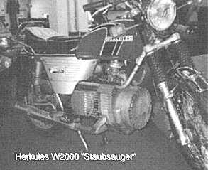 | Production began in 1974 with the KC 27 engine. The bike was sold in England as DKW because that name was more popular in England and Sachs owned the rights of that name, too. Special motorbikes based on the W 2000 have been driven in long-distance races and were very succesful in off-road sports. A 50,000 km endurance test at the Nürburgring in 1975 showed very low wear.
Hercules made prototype studies with a water-cooled engine in a BMW/5 frame and a more conventional looking engine on a 7 speed gearbox of the Hercules GS Two-stroke. For the last year of production the W 2000 got an oil-injector to avoid the mixing of fuel and oil. Overall 1800 Hercules W 2000 have been built. After stopping the production of rotary engines Sachs sold the tooling machines to Norton. There is a IG Hercules W 2000 in Germany, a DKW owners club in England and a "Rotary Recycle" in USA. They were made at least as late as 1977.
Capacity 1 rotor x 294 cc
Horsepower 27 bhp at 6500 rpm
Torque 35 Nm at 4500 rpm (24.5 ft-lb)
Brakes front disc, rear drums
Weight 174 kg
Max. Speed 140 km/h - 87 mph
Production 1834

An example is on display at the Ontario Science Centre in Toronto, Canada.
A Hercules W2000 can be seen at the "Barber Vintage Motorsports Museum" in downtown Birmingham, Alabama, where there are 325 motorcycles on display. It is open from 9 to 3 on Wednesdays and Fridays.
Jeff used to have a W-2000 and wrote a page about it.
DKW also made automobiles. There are clubs for enthusiasts:
DKW Club of America
c/o Byron Brill
260 Santa Margarita Ave.
Menlo Park, CA 94025 USA

(650) 321-6640
jowett@best.com
They offer information, technical support and a newsletter, "The Blue Cloud", three times a year. Membership is $15 annually, $20 outside of North America. An alternate source gives the address as DKW Club of America, 7011 Sunny Vista Rd., Joshua Tree, CA 92252. Ph (619) 366-9104. I think this is an old address, but it may be a new address, or a separate club. If you know, please e-mail the editor.
DKW Club Nederland: H. Broers, Kesterenlaan 110, 4822 WK Breda. Tel.: 076 5420404.
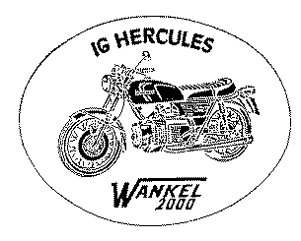
drawing courtesy of M. Hilgenfeld

